1. In a web crawler and search engine system, web pages are represented as nodes in
a graph, and page-to-page hyperlinks are represented as edges. Since each web
page typically links to only a few other pages, the adjacency matrix representing
these links contains a large number of zero entries. To optimize memory usage, the
page-to-page links are stored using a sparse matrix representation implemented with
arrays (3-tuple form). Given the sparse matrix representation of page-to-page links,
compute the transpose of the sparse matrix using arrays.

#include <stdio.h>
int main()
{
int matrix[10][10], sparse[50][3], transpose[50][3];
int rows, cols, i, j, k = 1;

printf("Enter number of rows and columns: ");
scanf("%d %d", &rows, &cols);
printf("Enter the matrix:\n");
for (i = 0; i < rows; i++)
for (j = 0; j < cols; j++)
scanf("%d", &matrix[i][j]);
sparse[0][0] = rows;
sparse[0][1] = cols;
for (i = 0; i < rows; i++)
{
for (j = 0; j < cols; j++)
{
if (matrix[i][j] != 0)
{sparse[k][0] = i;
sparse[k][1] = j;
sparse[k][2] = matrix[i][j];
k++;
}
}
}
sparse[0][2] = k - 1;
printf("\nSparse Matrix (Triplet Form):\n");
printf("Row Col Val\n");
for (i = 0; i <= sparse[0][2]; i++)
printf("%d %d %d\n", sparse[i][0], sparse[i][1],
sparse[i][2]);

transpose[0][0] = sparse[0][1];
transpose[0][1] = sparse[0][0];
transpose[0][2] = sparse[0][2];
k = 1;
for (i = 0; i < sparse[0][1]; i++)
{
for (j = 1; j <= sparse[0][2]; j++)
{
if (sparse[j][1] == i)
{
transpose[k][0] = sparse[j][1];
transpose[k][1] = sparse[j][0];
transpose[k][2] = sparse[j][2];
k++;
}
}
}

printf("\nTranspose of Sparse Matrix:\n");
printf("Row Col Val\n");
for (i = 0; i <= transpose[0][2]; i++)
printf("%d %d %d\n", transpose[i][0],
transpose[i][1], transpose[i][2]);
return 0;
}
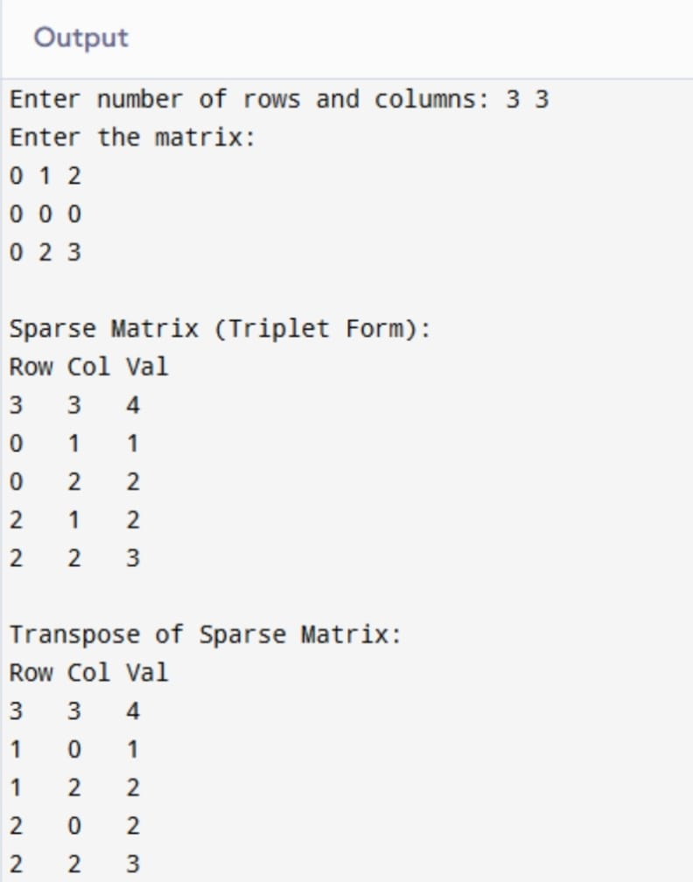

2. In an IoT-based environmental monitoring system, data collected from multiple sensors are stored in matrix form. Since most sensor readings are zero at any given time, the datasets are stored using sparse matrix representation implemented with arrays to reduce memory usage. Two sparse sensor datasets, collected from different regions, need to be merged to generate a consolidated dataset for further analysis. Write a C program to perform the addition of two sparse matrices using array-based sparse matrix representation.

#include <stdio.h>
int main()
{
int r1, c1, r2, c2;
int a[50][50], b[50][50];
int t1[100][3], t2[100][3], t3[200][3];
int i, j, k1 = 1, k2 = 1, k3 = 1;
printf("Enter rows and columns of Matrix 1: ");
scanf("%d %d", &r1, &c1);
printf("Enter elements of Matrix 1:\n");
for(i = 0; i < r1; i++)
for(j = 0; j < c1; j++)
scanf("%d", &a[i][j]);
printf("Enter rows and columns of Matrix 2: ");
scanf("%d %d", &r2, &c2);
printf("Enter elements of Matrix 2:\n");
for(i = 0; i < r2; i++)
for(j = 0; j < c2; j++)
scanf("%d", &b[i][j]);
if(r1 != r2 || c1 != c2)
{
printf("Size is not same");
return 0;
}
t1[0][0] = r1;
t1[0][1] = c1;
for(i = 0; i < r1; i++)
for(j = 0; j < c1; j++)
if(a[i][j] != 0)
{
t1[k1][0] = i;
t1[k1][1] = j;
t1[k1][2] = a[i][j];
k1++;
}
t1[0][2] = k1 - 1;
t2[0][0] = r2;
t2[0][1] = c2;
for(i = 0; i < r2; i++)
for(j = 0; j < c2; j++)
if(b[i][j] != 0)
{
t2[k2][0] = i;
t2[k2][1] = j;
t2[k2][2] = b[i][j];
k2++;
}
t2[0][2] = k2 - 1;
printf("\nSparse Matrix 1 (Triplet Form):\n");
for(i = 0; i < k1; i++)
printf("%d %d %d\n", t1[i][0], t1[i][1], t1[i][2]);
printf("\nSparse Matrix 2 (Triplet Form):\n");
for(i = 0; i < k2; i++)
printf("%d %d %d\n", t2[i][0], t2[i][1], t2[i][2]);
i = 1;
j = 1;
t3[0][0] = r1;
t3[0][1] = c1;
while(i < k1 && j < k2)
{
if(t1[i][0] == t2[j][0] && t1[i][1] == t2[j][1])
{
t3[k3][0] = t1[i][0];
t3[k3][1] = t1[i][1];
t3[k3][2] = t1[i][2] + t2[j][2];
i++;
j++;
k3++;
}
else if(t1[i][0] < t2[j][0] || (t1[i][0] == t2[j][0] &&
t1[i][1] < t2[j][1]))
{
t3[k3][0] = t1[i][0];
t3[k3][1] = t1[i][1];
t3[k3][2] = t1[i][2];
i++;
k3++;
}
else
{
t3[k3][0] = t2[j][0];
t3[k3][1] = t2[j][1];
t3[k3][2] = t2[j][2];
j++;
k3++;
}
}
while(i < k1)
{
t3[k3][0] = t1[i][0];
t3[k3][1] = t1[i][1];
t3[k3][2] = t1[i][2];
i++;
k3++;
}
while(j < k2)
{
t3[k3][0] = t2[j][0];
t3[k3][1] = t2[j][1];
t3[k3][2] = t2[j][2];
j++;
k3++;
}
t3[0][2] = k3 - 1;
printf("\nSum Sparse Matrix (Triplet Form):\n");
for(i = 0; i < k3; i++)
printf("%d %d %d\n", t3[i][0], t3[i][1], t3[i][2]);
return 0;
}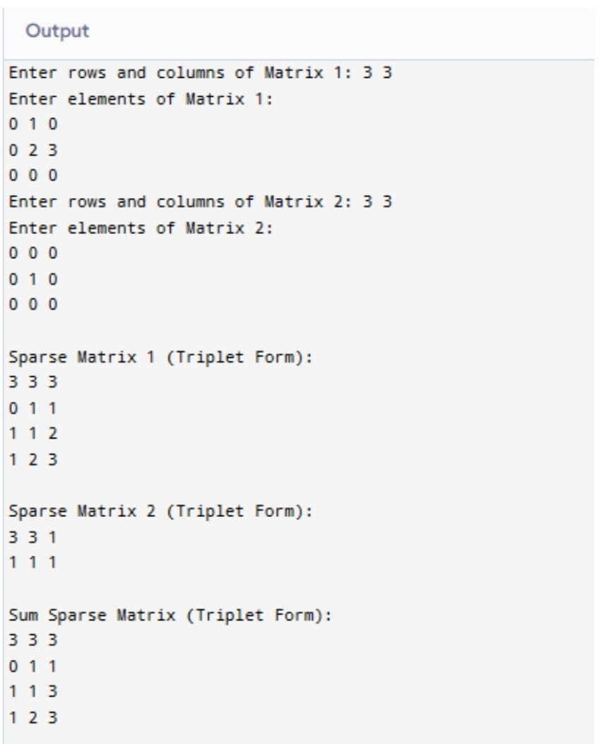

3. In an electrical power grid management system, daily power consumption patterns
are modeled using polynomial equations, where each term represents the
contribution of different factors such as industrial load, residential usage, and peak-
hour demand. These polynomial equations are stored using arrays to facilitate
efficient computation. To analyze the combined power consumption from two different
regions, the system needs to add two polynomial equations. (Implement in C
language)

#include <stdio.h>
int main()
{
int n, i;
int p1[50], p2[50], sum[50];
printf("Enter degree of polynomial: ");
scanf("%d", &n);
printf("Enter coefficients of first polynomial:\n");
for(i = 0; i <= n; i++)
scanf("%d", &p1[i]);
printf("Enter coefficients of second polynomial:\n");
for(i = 0; i <= n; i++)
scanf("%d", &p2[i]);
for(i = 0; i <= n; i++)
sum[i] = p1[i] + p2[i];
printf("Resultant polynomial:\n");
for(i = n; i >= 0; i--)
{
if(sum[i] != 0)
{
if(i == 0)
printf("%d", sum[i]);
else
printf("%dx^%d + ", sum[i], i);
} return 0; }
}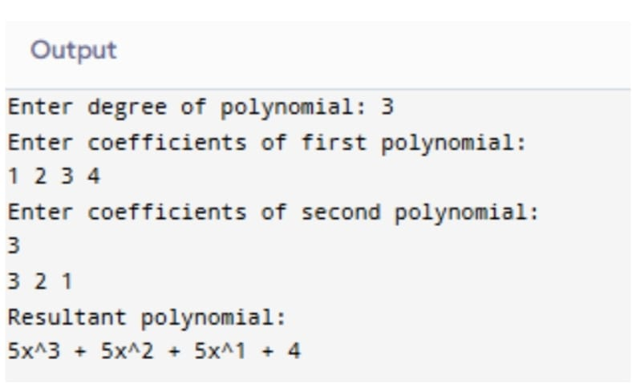
4. In a digital signal processing (DSP) system, digital filters are commonly represented
using polynomial equations, where the coefficients correspond to filter weights and
the exponents represent delay elements. Suppose two digital filters are represented
as polynomials stored using arrays. To analyze the combined effect of applying both
filters in sequence, the system needs to compute the multiplication of the two
polynomials.
Task:
Write a C program to: Store two polynomials using arrays, Perform polynomial
multiplication, Display the resulting polynomial in standard form.

#include <stdio.h>
int main()
{
int d1, d2, i, j;
int p1[50], p2[50], res[100];
printf("Enter degree of first polynomial: ");
scanf("%d", &d1);
printf("Enter coefficients of first polynomial:\n");
for(i = 0; i <= d1; i++)
scanf("%d", &p1[i]);
printf("Enter degree of second polynomial: ");
scanf("%d", &d);
printf("Enter coefficients of second polynomial:\n");
for(i = 0; i <= d2; i++)
scanf("%d", &p2[i]);
for(i = 0; i <= d1 + d2; i++)
res[i] = 0;
for(i = 0; i <= d1; i++)
for(j = 0; j <= d2; j++)
res[i + j] += p1[i] * p2[j];
printf("Resultant polynomial:\n");
for(i = d1 + d2; i >= 0; i--)
{
if(res[i] != 0)
{
if(i == 0)
printf("%d", res[i]);
else
printf("%dx^%d + ", res[i], i);
}
}
return 0;
}

